Frontend Development with React.js

Project Documentation

CRYPTOVERSE-CRYPTOCURENCY DASHBOARD

TEAM Details:

Team ID**: SWTID1741151600**

Team Size: **5**

Team Leader: **SHANMUGAM D(Ideation, Documentation, Demonstration) –**[**shanmugamd0305@gmail.com**](mailto:shanmugamd0305@gmail.com)

Team Member2: **VAITHISWARAN C (API Integration Specialist, Branch Management)-**[**vvaithis527@gmail.com**](mailto:vvaithis527@gmail.com)

Team Member3: **VISHAL J (Frontend Developer) -**[**vv348629@gmail.com**](mailto:vv348629@gmail.com)

Team Member4: **KALANITHI S (Execution Specialist) -**[**kalanithikala37@gmail.com**](mailto:kalanithikala37@gmail.com)

Team Member5: **YUVARAJ S (Environment Supervisor) -**[**yuvarjs622@gmail.com**](mailto:yuvarjs622@gmail.com)

**Introduction:**

Cryptoverse is an innovative and user-friendly web application designed to cater to cryptocurrency enthusiasts and investors alike. With a vast database comprising details of over 200 cryptocurrencies and information on 50 different country currencies, Cryptoverse offers a one-stop platform for all your cryptocurrency-related needs. Whether you are a beginner exploring the world of digital assets or an experienced investor seeking in-depth analysis and real-time data.

**Purpose:**

* The purpose of the Cryptoverse project is to provide a comprehensive and user-friendly platform for cryptocurrency enthusiasts and investors. By consolidating essential tools and information into a single web application, Cryptoverse aims to simplify the process of navigating the complex world of cryptocurrencies and empower users to make informed decisions for their financial success.
* Cryptoverse offers a wide range of features, including an extensive cryptocurrency database, interactive charts, currency converter, cryptocurrency news section, portfolio tracking, and personalized recommendations. These features are designed to cater to both beginners and experienced investors, making it easier for users to access valuable insights and real-time data1.
* In essence, Cryptoverse serves as a reliable and comprehensive source of information for cryptocurrencies, prioritizing user experience with its intuitive and user-friendly interface. By providing all the relevant information in one place, Cryptoverse saves users time and effort in searching multiple platforms for the data they need

**Component Structure:**

The Cryptoverse project follows a modular approach, where components are categorized into reusable UI elements:

* **Navbar Component**: Contains site navigation and search bar, allowing users to easily navigate through different sections of the Cryptoverse platform.
* **Hero Component**: Displays featured cryptocurrency news articles, providing users with the latest updates and important information about the crypto market.
* **Categories Component**: Shows different news categories related to cryptocurrencies, enabling users to explore news articles based on specific topics of interest.
* **NewsCard Component**: Renders individual cryptocurrency news articles, offering users detailed information and insights about various crypto-related events and developments.
* **Footer Component**: Contains site information and links, helping users access additional resources and contact information related to the Cryptoverse platform.
* **Context API**: Manages global state, ensuring that data flows seamlessly across different components and providing a consistent user experience throughout the application.

**State Management:**

The Cryptoverse application uses the React Context API for global state management, ensuring seamless data flow across components. This allows the application to maintain a consistent and up-to-date state, providing users with accurate and real-time information about cryptocurrencies.

**Routing:**

The application utilizes React Router DOM for seamless navigation across different pages. Users can effortlessly switch between various sections of the Cryptoverse platform, such as the cryptocurrency database, news section, portfolio tracker, and more, without experiencing any interruptions or delays.

By employing these components and technologies, Cryptoverse offers a smooth and intuitive user experience, making it easier for users to navigate the complex world of cryptocurrencies.

**Prerequisites:**

To set up the Cryptoverse project, ensure you have the following prerequisites installed and configured:

* **Node.js & npm**: Install and configure for JavaScript execution. You can download Node.js from here.
* **Git Version Control**: Use platforms like GitHub for collaboration and version control. You can download Git from here.
* **Development Environment**: It is recommended to use editors such as Visual Studio Code, Sublime Text, or WebStorm for an optimal development experience.
* Git Version Control: Use platforms like GitHub for collaboration.
* Git: Download and installation instructions can be found at:https://git-scm.com/downloads/
* Development Environment: Recommended editors include -Visual Studio Code, Sublime Text.
* Visual Studio Code: Download from https://code.visualstudio.com/download
* Sublime Text: Download from https://www.sublimetext.com/download

**Installation:**

Follow these steps to clone the repository and install the dependencies:

1. **Clone the Repository**:

bash

git :<https://github.com/Shanmugam-D/Cryptocurrency_cryptoverse>

1. **Navigate to the Project Directory**:

bash

*cd Cryptoverse*

1. **Install Dependencies**:

bash

*npm install*

Once the dependencies are installed, you can start the development server and explore the Cryptoverse project on your local machine.

By following these setup instructions, you'll be ready to dive into the Cryptoverse project and start developing or exploring the features it offers.

**Project Structure:**

The project is organized into four primary folders:

Components: Houses reusable UI elements.

Context: Contains the Context API for global state

management.

Pages: Stores page-specific components that map to different

URLs.

Styles: Includes all CSS files for styling.

**Project Milestones:**

Milestone 1: Project Setup & Configuration

Install necessary tools including React.js, React Router DOM,

Axios, and Tailwind CSS.

Set up the basic project structure.

Open the project folder to install necessary tools. In this

project, we use:

• React.js

• React Router Dom

• React Icons

• Bootstrap/Tailwind CSS

• Axios

For further reference, use the following resources

https://react.dev/learn/installation

https://react-bootstrap-v4.netlify.app/getting-

started/introduction/

https://axios-http.com/docs/intro

https://reactrouter.com/en/main/start/tutorial

Milestone 2: Development Phase

• Conceptualization & Planning

**Define the vision**: What will the cryptoverse offer (gaming,

social, commerce, etc.)?

Select the blockchain: Ethereum, Solana, or a custom chain?

Identify token utility: Governance, transactions, staking, etc.

Research market trends and competitors.

• Blockchain & Smart Contract Development

Develop smart contracts for tokens, NFTs, and in-game assets.

Build a native token and set up liquidity pools

**Fetching crypto currency via API:**

Create a redux store: have a fully functional Redux store with

a counter slice, and you can integrate it into your React app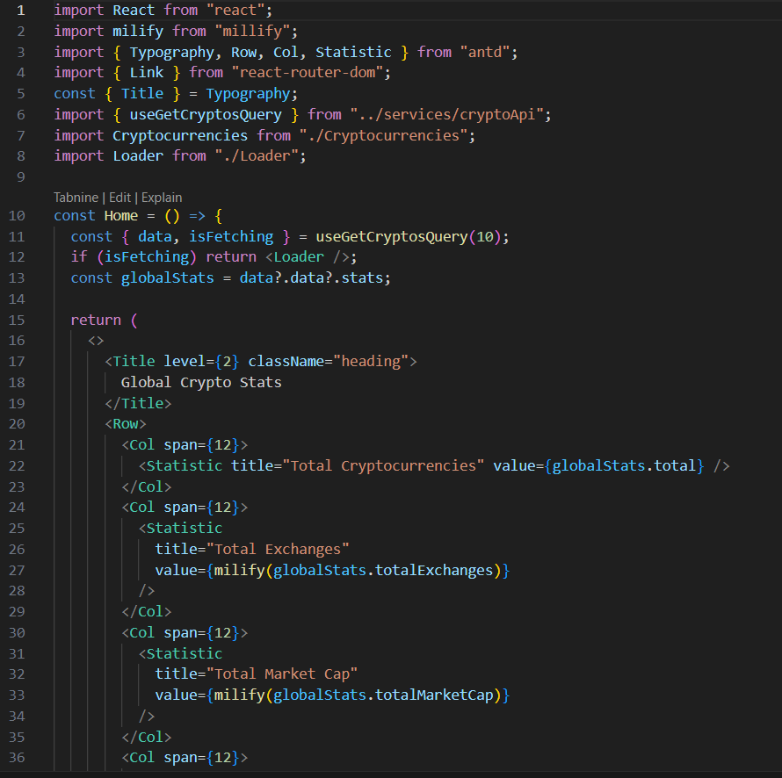

**Create a component to show the details of**

**cryptocurrency**:

This code defines a React functional component called

CryptoDetails responsible displaying detailed information

about a specific cryptocurrency.

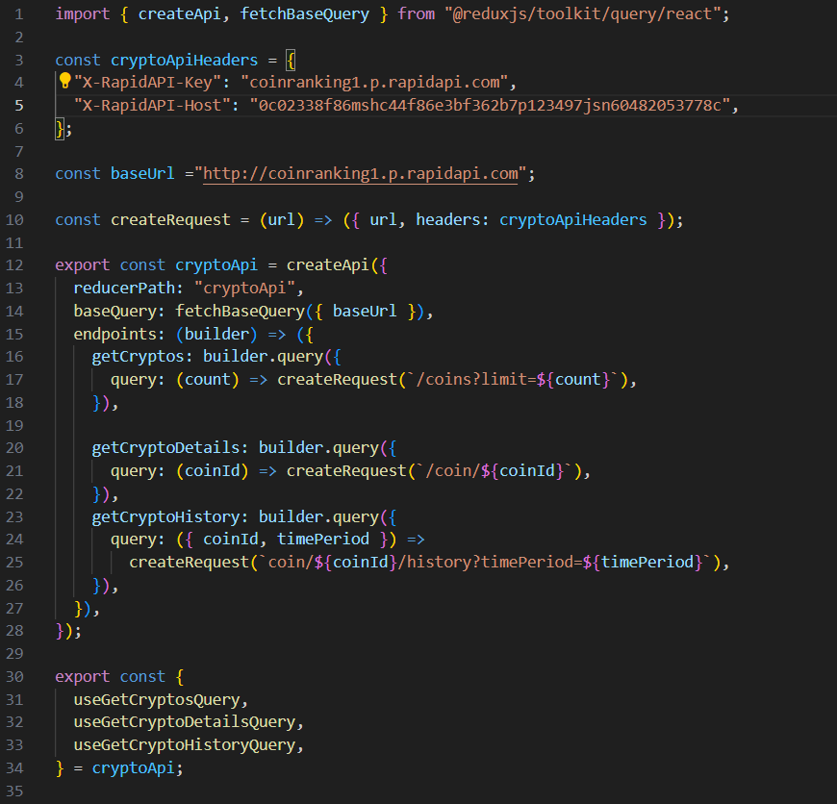

Create a Homepage:

This component, named Home, is a React functional

component responsible for rendering the home page of the

cryptocurrency dashboard.

**Project Execution:**

Once the development is complete, start the application

using:

npm start

This will launch the app at http://localhost:5173/, displaying

**USER SNIPPETS:**

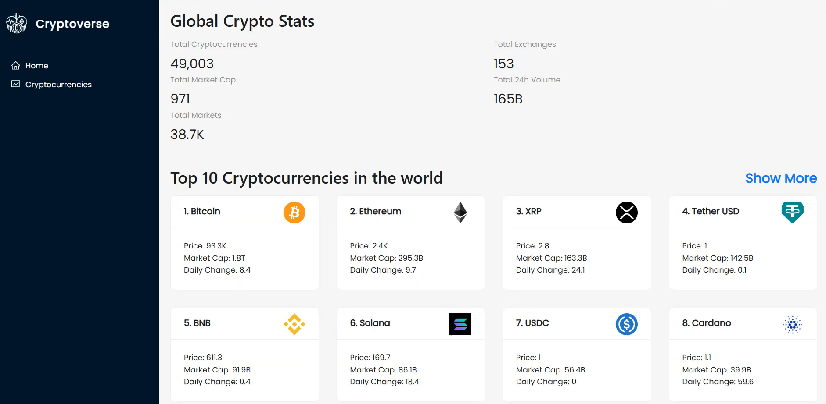

**Home page**: This pages consists of stats of global crypto like

total cryptocurrencies total exchanges, market cap etc. Also

consist of top 10 cryptocurrencies in the world.

**Crypto currencies page**: This page contains all

cryptocurrencies which ar currently in flow in the world. There

is also a search feature where users can search and find out

about their desired cryptocurrency

Crypto currency details page : This page contains the line chart

with the representation of price of cryptocurrencies. Also contains statistics and website links of cryptocurrencies